Name(s)_______________________________________________ Period ______ Date ___________________

|  |  |  |
| --- | --- | --- |
|  | **Activity Guide - Loops Make** |  |

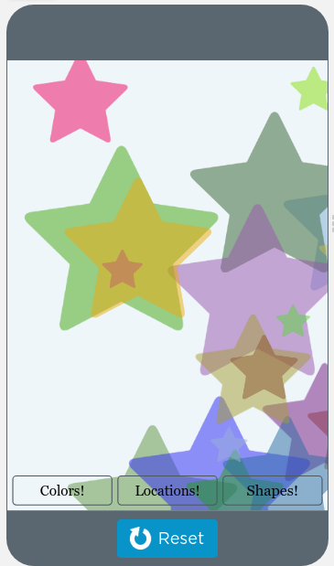

Twenty images with IDs   
"icon0", "icon1" … "icon19"

"colorsButton"

"locationsButton"

"shapesButton"

"homeScreen"

**Step 1 - Try the app**

Try using the different combinations of inputs.

* What does each button change and what does it not change?

Discuss with a Partner

* Where (if at all) do you think this app is using a list?
* Where (if at all) do you think this app is using a loop?

**Step 2 - Plan**

Fill in the information in the table below for each event handler you'll need to create

|  |  |
| --- | --- |
| **Element ID** | **Description of What the Event Handler will Do** |
|  |  |
|  |  |
|  |  |

Fill in the table below for each variable you'll need to create.

|  |  |
| --- | --- |
| **Variable Name** | **What the Variable Stores** |
|  |  |
|  |  |

**Step 3 - Write Your Code**

* Write the code for the app, using your plan above and the comments provided in Code Studio to help
* Steps You Can Follow
  + Create all the variables from your table above.
  + Give your variables a starting value using the assignment operator (=).
  + Create blank event handlers (onEvent) for each screen element in your table above.
  + Write the code to make each of the three buttons work.
  + HInt: in order to create random colors use the rgba() block with randomNumber(). Read the documentation for those blocks if you need more help.
  + Use your debugging skills to identify unexpected behavior and fix your program.
  + Comment your code as you go, explaining what each event handler does.
* Extension Ideas
  + Create a way to hide the three buttons when you have a lock screen that you like
  + Add sounds to each button.
  + Change the code for the "shapes" button to guarantee that you never randomly get the same shape twice in a row.

**Step 4 - Submit**

Before your submit check the rubric below to make sure your program

|  |  |  |  |  |
| --- | --- | --- | --- | --- |
| **Category** | **Extensive Evidence** | **Convincing Evidence** | **Limited Evidence** | **No Evidence** |
| Input | onEvents are created for all the required inputs. | onEvents are created for most of the inputs. | onEvents are created for some of the inputs. | onEvents are not created for any inputs. |
| Variables and Lists | Variables and lists are created and appropriately used for all pieces of information used in the app. | Variables and lists are created and appropriately used for most pieces of information used in the app. | Some information is stored in variables and lists and appropriately updated throughout the app. | There are no variables or lists which store the necessary information for the app to work correctly. |
| Loops | The program correctly uses loops for all three buttons to generate the expected output. | The program correctly uses a loop for two of the buttons to generate the expected output. | The program correctly uses lists for one of the buttons to generate the expected output. | The program does not include or correctly use any loops. |
| Output | All three buttons work as expected to move icons, change their colors, and change their icon to a random new icon. | Only two of the buttons work as expected. | Only one of the buttons work as expected. | None of the buttons work as expected. |
| Code runs without errors. | No errors are present in the required code. | Some errors are present in the required code. | Many errors are present in the required code. | The code does not run. |
| Comments | Comments are used to correctly explain the purpose and functionality of both the function and event handlers. | Comments are used to explain the purpose and functionality of either the function or event handlers. | Comments are present, but are not used to explain the purpose or functionality of the function or event handlers. | Comments are not present. |